Savitribai Phule Pune University



A Project Base Learning Report

On

E-commerce Website

Development {SANTRA}
Submitted by
Mr. Krishna Birla F190610034
Mr. Adi Golandaj F190610099
Mr. Parth Arudkar F190610015
Mr. Bhavesh Makhija F190610173
Mrs. Ashwini Ahir F
Mrs. Shreya Banarase S190814265
Under the guidance of
Prof. Sharda Thete


Department of Computer Engineering

ISB&M COLLEGE OF ENGINEERING.
College Engineering, Nande.
[2022-23]


C E R T I F I C A T E

This is to certify that the project work entitled

E-commerce Website Development {SANTRA}

Submitted by :

Mr. Aman Singh S190814289
Mr. Vijay Singh S190814298
Mr. Anurag Yesansure S190814302
Mr . Gaurav Pandey S190814262
Mr. Shashwat Pandey S190814280
Mr. Atharv Patil S190814265

is a bonafide work carried out by a student of this institute in partial fulfilment for the PBL-II in Second Year Computer Engineering of the Savitribai Phule Pune University during the year 2022-23. It certifies that all the corrections/suggestions indicated for internal assessment have been incorporated in the report deposited in the department library. The PBL-II report has been approved as it satisfies the academic requirements in respect of the project work prescribed for the degree.

Prof. Sharda Thete Prof . Balasaheb Githe
Guide Head of Department
Dept of Computer Engineering Dept of Computer Engineering
(Dr. P. K . SRIVASTAVA)
Principal,
ISB&M COE, NANDE, PUNE.
Place: Pune
Date:

ACKNOWLEDGEMENT

It gives us immense pleasure to express our gratitude and thanks to all those who helped in the timely completion of the PBL work.
We have great pleasure in expressing our deep sense of gratitude and indebtedness to Prof. Sharda Thete Guide for their invaluable guidance, constant supervision and sustained encouragement throughout the tenure in this dissertation work.
We would like to express our thanks to, Prof Balasaheb Githe, Head of Department, Department of Computer Engineering, ISB&M College Of Engineering for their constant support and encouragement.
We would like to express our thanks to Dr. P. K. SRIVASTAVA Principal, ISB&M college of engineering,nande Pune for permitting us to take up the project work.
We are thankful to our parents and friends for their kind help and support throughout the course.

Name Of the Students :
Aman Singh
Vijay Singh
Gaurav Pandey
Anurag Yesansure
Atharv Patil
Shashwat Pandey

ABSTRACT

Online Business-to-Consumer aspect of product commerce (e-commerce) is the most visible business use of the world wide web. The primary goal of an e-commerce site is to sell goods online.
This project deals with developing an e-commerce website for Online Product Sales. It provides the user with a catalog of different products available for purchase in the store. In order to facilitate online purchase a shopping cart is provided to the user. The system is implemented using Only the Front End Approach Currently.
Taking a web browser as a front-end client, in order to develop an e-commerce website, a number of Technologies must be studied and understood.
These include multi-tiered architecture, server and client-side scripting techniques, and implementation technologies such as PHP(OOP), JQUERY, BOOTSTRAP, HTML5, and relational databases (such as MySQL, access). This is a project with the objective to develop a basic website where a consumer is provided with a shopping cart application and also to know about the technologies used to develop such an application. This document will discuss each of the underlying technologies to create and implement an e-commerce website.

TABLE OF CONTENTS

Acknowledgment i
Abstract ii
INDEX iii
List of figures iv
List of table v
Nomenclature vi
- Introduction................................................................................... .07
- Project Details…………………………………………………….. .08
- Sections 1) home 2) shop 3)blog 4) about 5)contact 6) cart .08-14
- What is the Front-end? ……………………………………………………… …….. .15-16
- Literature survey.......................................................................... .17-18
- Conclusion……………………………………………… ………… 19
- References...................................................................................... .20

LIST OF FIGURE

Figure | Description | Page No
Figure1.1 | Project front end | 1
Figure2.1 | Logo | 2
Figure2.2 | Navbar | 2
Figure2.3 | Hero page | 2
Figure2.4 | Banner Section | 3
Figure2.5 | More banners | 3
Figure3.1 | Header banner for shop page | 3
Figure3.2 | products | 4
Figure3.3 | Detailed products | 4
Figure3.4 | Featured products | 4
Figure4.1 | Header banner for blog page | 5
Figure4.2 | Product blog | 5
Figure5.1 | Header banner for about page | 6
Figure5.2 | Download app section | 6
Figure5.3 | Features | 6
Figure6.1 | Header banner for contact page | 7
Figure6.2 | map | 7
Figure6.3 | Contact details | 7
Figure7.1 | Cart page | 8
Figure7.2 | Cart total | 8
Figure7.3 | Apply coupon | 8

INTRODUCTION

E-commerce is fast gaining ground as an accepted and used business paradigm. More and more business houses are implementing websites providing functionality for performing commercial transactions over the web. It is reasonable to say that the process of shopping on the web is becoming commonplace.
The objective of this project is to develop a Clothing e-commerce store where any kind of product can be listed and bought from the comfort of home through the internet. However, for implementation purposes, this paper will deal with online shopping for clothes
An online store is a virtual store on the internet where customers can browse the catalogue and select products of their own personal interests. The selected items may be collected in a shopping cart.
The business-to-consumer aspect of product commerce (e-commerce) is the most visible business use of the world wide web. The primary goal of an e-commerce site is to sell goods online.
This project deals with developing an e-commerce website for Online product sales. It provides the user with a catalogue of different products available for purchase in the store. In order to facilitate online purchase a shopping cart is provided to the user.
This was a project with only front-end capabilities, this had nothing to do with the server-side applications. At the end of this project, we were successfully able to see different types of buttons, taskbars, input sections, links and others.
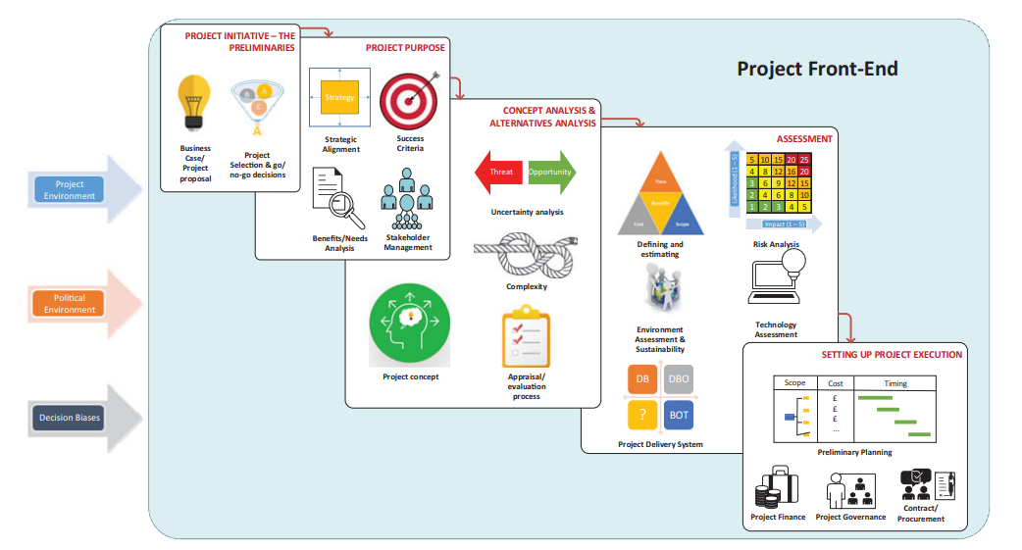

Project Details:

Section 1: HOME page –
We started our project by creating our logo on an online website i.e. adobe.com, then after we have to create our navbar first and insert this logo there. for that, we have created our class logo for styling and positioning this logo


The above screenshot describes different sections we are able to see on initializing the home page at the very top. These are our later pages and active links. the logo of the cart is inserted using a CDN link tag from font-awesome icons later on our hero section appears with different heading tags and a shop now button as shown below…

The “Shop now” button is an active button but currently, it is navigated to nowhere but refreshes the home page. later on, we have shown different images of the products that we are selling. there are different banners that we have included in our home page some of the screenshots are given below


The above banner contains image from one of our sources, below it we listed a button for exploring more such contents .

These are some other banners we included around the newsletter section .

Section 2: SHOP Page –
On the shop page, we have listed different types of clothing materials. The shop page starts with the same old navbar but this time we have used an active link for the shop page so, the shop page section in the navbar must be highlighted.
Later we have a page header section in which we used an image from our databases in which it contain different heading tags

Later on, we can see our product pages in which we have created boxes, box shadows for different products which are listed there. we have created an direct add-to-cart button through which customers can directly add their product to the cart
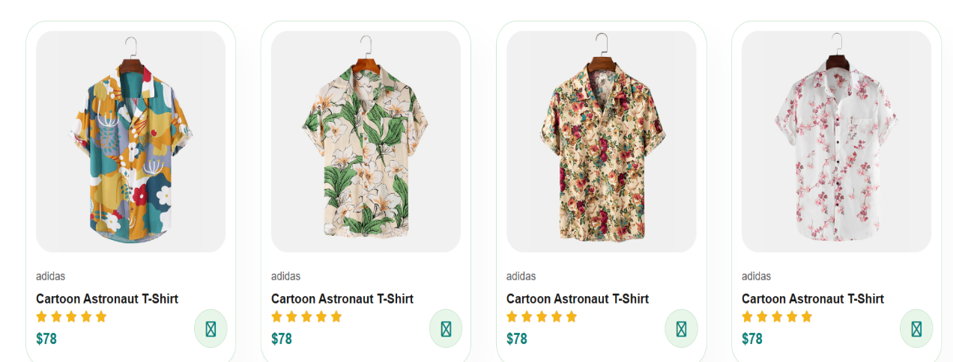
After clicking the first product we can be directed to the product detail page in which we can see the product size , product quantity and the add to cart button which allows customer to add their preferable product in the cart.

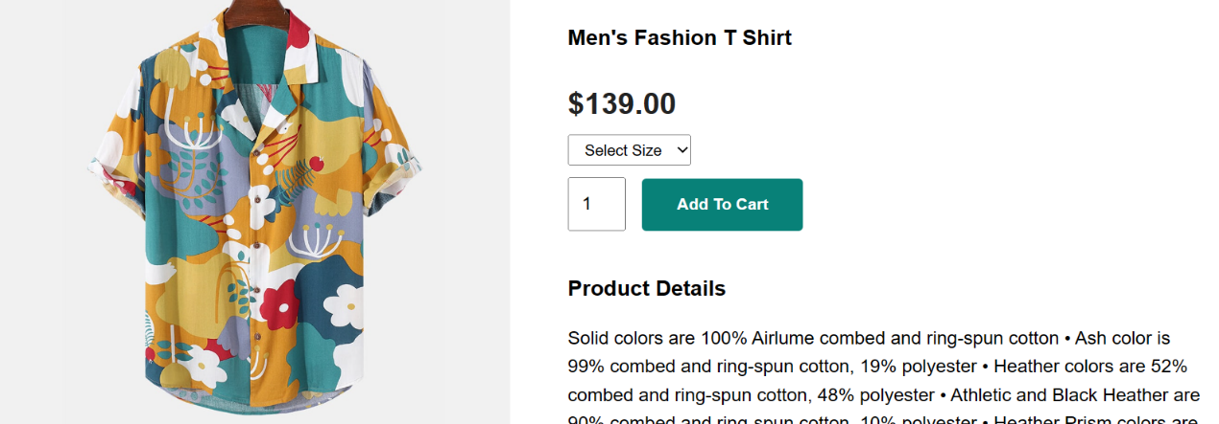
Below that we have created some featured product sections through which customers can view other related products to the product customer have chosen
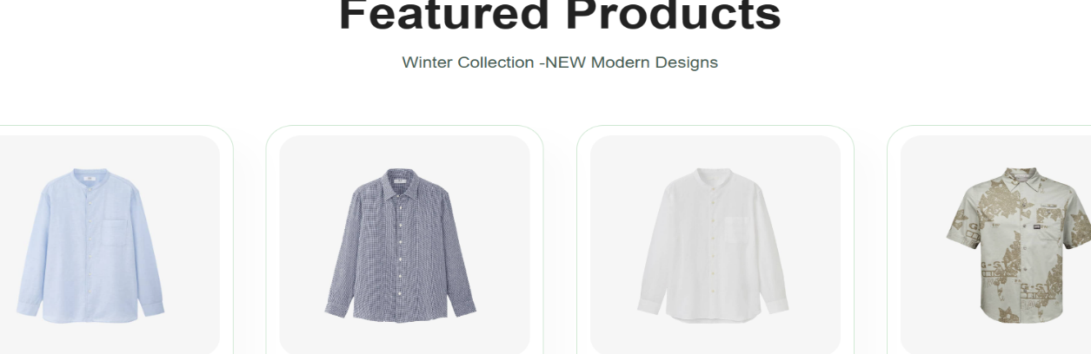

Section 3: BLOG Page -
The third section contains different blogs and research about our products.
The blog page starts with the same old header section but this time we have added the active link to our blog page so the blog page should be active.
The blog page features the header banner which contains an image from one of our databases and different types of headings.



Below that there are n number of case studies related to our project and a continue reading button which allows customers to read further more and a detailed report about an project



Section 4:ABOUT Page –
Later on, we have created our about page , it starts with the same old navbar which contains different sections eg. Home page , shop page , blog page , cart page and about page.
This time we have created an active link in the about page so that it should be highlighted in the navbar sections .

This page majorly focus on knowing the developers and what other features this site has, it has a active link tag that allows user to directly download the app from the app store and play store ﻿.below it we have an featured video which is played on the loop again and again so that it won’t end after some time.
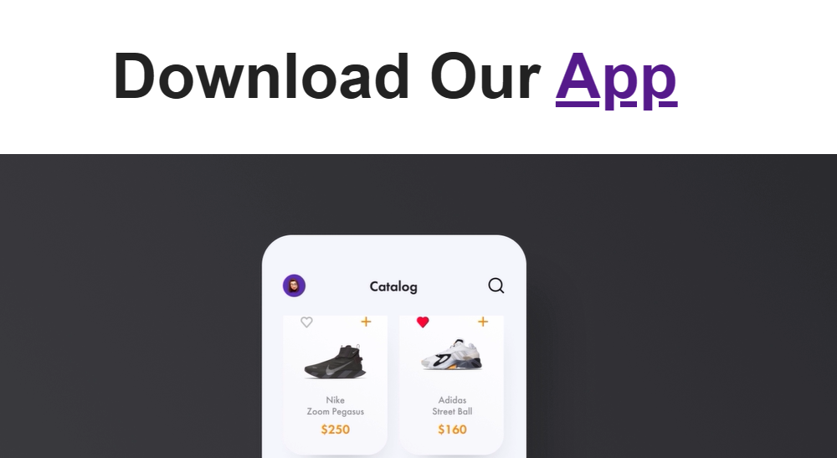
Below that there is another section which describes the different features about this site
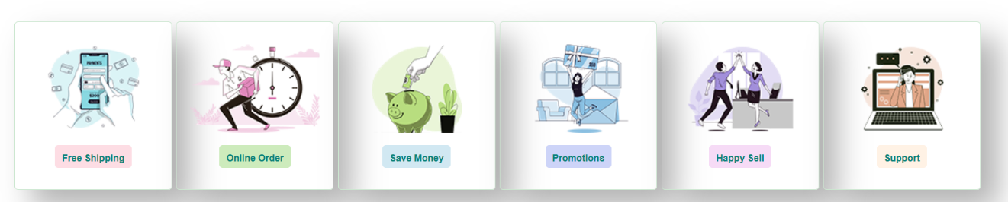
Section 5: CONTACT Page –
After the About page, we created the contact page to make the website safer side. here the first section is the navbar section again we have used an active link on the contact page. After that, there is a header banner which is an image taken from one of our databases

After that, we have embedded a map of our location so can anyone can contact us directly in case.

Again we have used font awesome icons and created bullets with the help of them . we have displayed all necessary information related to us.

Section 5: CART Page -
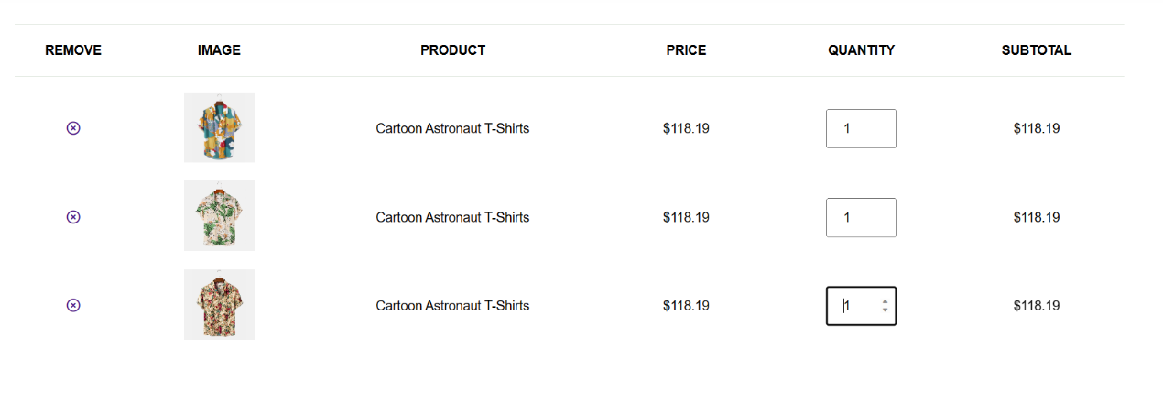
The cart page is a section in which the total products added in a cart can be seen . it is an checkout gateway through which customers are applicable to pay certain amount after they choose to buy an certain item .
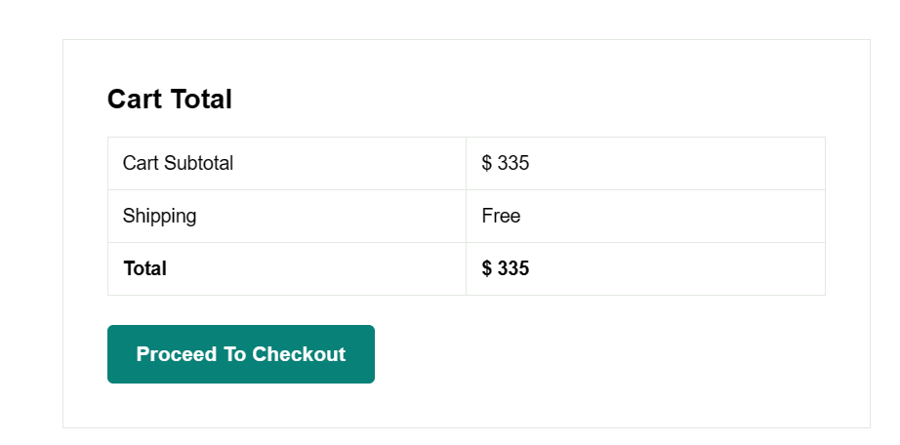
There is also an apply coupon section which helps user /customers to apply certain coupons they might have in case.



What is the Front-end?
The definition of the ‘front-end’ of the project is bound up with the definition of what a ‘project’ is. Morris (2016) distinguishes between those that see the front-end as the vital ‘shaping’ part of a potential project, and those that see the project only starting once the ‘front-end’ is completed. Edkins and Smith (2012, 138) note that there is not agreement on the definition, but conclude that there is agreement (and evidence) that ‘the early stages of a project are one of the primary points where strategic success or failure for the project is set’. Certain developments need to occur before the project proper starts, as shown in Table 1 below, and these all need to occur in the ‘front-end’. A project results when an organization or party has a desire to achieve a particular change or outcome. When this desire is sufficiently specified and formalized, a person or organization is nominated and/or delegated to undertake a defined project, whose output is deemed appropriate to achieving or contributing to that change or outcome. The organization which initiates the project and desires the project outcome has been called the ‘permanent organization’ although we will see below that the terminology varies. This is in contrast to the extensive literature around the phrase the ‘temporary organization’ for the entity that undertakes the project. Often the project is undertaken by an entirely separate organization (‘the contractor’s job is to deliver a project as specified, on time and budget; the owner’s job is to specify the right project’ [Merrow 2011, 126]). However, a ‘project’ does not necessarily imply the existence of a separate organization or indeed the existence of an organizational structure (although it is difficult to imagine executing a project of any size without some sort of organizing). Indeed, early work on matrix organization assumed team structures superimposed upon the permanent organization structure. Bakker’s (2010) review of organizing talks about ‘temporary organizational forms’ rather than temporary organizations. The important element here is the permanent organization and its definition of its needs. The nature of the organization or structure undertaking the project is actually a decision to be made in the front-end of the project. But the undertaking or project is temporary - or more properly ‘determinate’ (i.e. it has a foreseeable and pre-agreed delivery objective and end-time) as defined by Winch (2014). The review of the ‘front-end’ of the project will thus engage with the period up until the permanent organization tasks the person or organization who is to be responsible for delivering the project

LITERATURE SURVEY
THE FRONT END OF PROJECTS by Terry Williams: This report describes the results of a detailed, comprehensive, systematic literature survey on the front end of a project, commissioned by the Project Management Institute (PMI). It is the result of a collaborative project conducted by academics from University College London, UK, the University of Hull, UK, and the Concept programme based at the Norwegian University of Science and Technology. The literature on the front end itself has been found to be fairly sparse; although the front end of a project has been shown to be critical to its strategic success or failure, this phase of a project’s life cycle is not well understood. This report presents the literature on the concept of the front end, and defines a temporarily ordered structure of generic processes that form part of the “front end” and how these fit together as a coherent whole (see Figure 2). These start from the preliminaries to the initiative, then the project purpose (for various stakeholders), initial analysis and scenario analysis; the analysis of alternatives and choice of project concept; assessment of the project (scope; estimation of cost, benefits, and schedule; risk; technology and sustainability; and the project delivery system), finishing with setting up the project execution (finance, governance, and contracts).
The report then looks at the recent literature on each of these elements in turn, specifically as they relate to the front end of the project, to provide a reference for each of these elements. This report does not take any specific theoretical stance but is informed by a clustering of the seven “images,” Winter and Szxczepanek (2009) keeping attention on the surrounding environment, the intended project benefits, and the temporariness of the project. The report finishes with some particular areas where further research would be valuable

A Literature Survey on Project Management Web Portal by Xiteej Wankhede: In this project by using various analyzing tools and various algorithms we are proposing a “Project management web portal”. Project management web portal systems are designed to manage and store project information that is used in web-based applications. Different groups of people such as the sales department, programmers or project managers will be let by project applications controlled access to information and automated distribution of information. The objective for collaboration has been: getting things done faster, cheaper and better by applying their common knowledge and bringing together a selection of resources and attainments in a project. Because valid collaboration with teams improves productivity, speeds up result-making and optimizes making the right decisions, it also helps to intercept precious intellectual fortune and time.
In this proposed system we can implement a system which can manage project cognate all work consummated by utilized and Project coordinator or guide. The coordinator updates project cognate information, view work done by a student at which time and view the progress chart of work done by the student, progress chart is developed utilizing WBS (“Work Breakdown Structure”). Student retrieved the given work information updates and consummates this work at given time and submits into the project management system. The system architecture is the conceptual design that defines the structure and/or behaviour of a system. An architecture description is a formal description of a system, organized in a way that supports reasoning about the structural properties of the system. It defines the system components or building blocks and provides a plan from which products can be procured, and systems developed, that will work together to implement the overall system. System Architecture, Defining the architecture as the set of relationships between the components of a system, that jointly ensures emergent properties of the system as a whole. The architecture of a system is the set of relationships between its components that cause the system to have desired properties, such as desired functionality, behaviour, semantics and quality of service

CONCLUSION
The business-to-consumer aspect of product commerce (e-commerce) is the most visible business use of the world wide web. The primary goal of an e-commerce site is to sell goods online.
This project deals with developing an e-commerce website for Online product sales. It provides the user with a catalogue of different products available for purchase in the store. In order to facilitate online purchase a shopping cart is provided to the user.
This was a project with only front-end capabilities, this had nothing to do with the server-side applications. At the end of this project, we were successfully able to see different types of buttons, taskbars, input sections, links and others.
One of the greatest lessons I have learned about frontend architecture over the life of this project is that, as with any good architect, your job is never finished until the last stone has been laid. We started this project with a very simple scope, and we created an architecture that met our needs at that time. But over time, our needs changed, the project evolved, and successes in one area turned into opportunities in others.

REFERENCES

- Agarwal, N., & Rathod, U. (2006). Defining ‘success’ for software projects: An exploratory revelation. International Journal of Project Management, 24(4), 358–370. doi: 10.1016/j.ijproman.2005.11.009

- Browning, T. R. (2014). A quantitative framework for managing project value, risk, and opportunity. IEEE Transactions on Engineering Management, 61(4), 583–598. doi: 10.1109/TEM.2014.2326986

- https://youtube.com//Apnacollege//htmlbasics A video by a Youtube channel, for learning Html basics

